Hybrid machine learning–geostatistical modelling of soil quality in in saline–sodic soils under arid agroecosystems of northwestern Peru
ABSTRACT
Soil fertility management in mango and banana production systems in northern Peru is limited by marked spatial heterogeneity, driven by chemical imbalances, particularly salinity, alkalinity, and sodicity. This study developed a spatial predictive framework to assess soil quality across the agricultural area of Morropón Province, Piura, by integrating a weighted Soil Quality Index (SQIw), specifically designed to diagnose salinity-, sodicity-, and alkalinity-related constraints, with hybrid machine learning–geostatistical modelling. Soil sampling was carried out in homogeneous units delimited according to slope, texture, and soil color. Within each unit, subsamples were composed of the 0-30 cm layer, resulting in 1304 observations representative of mango and banana fields. The SQIw was constructed using laboratory-derived physicochemical soil properties combined with environmental covariates, including vegetation indices extracted from Sentinel-2 images in Google Earth Engine. A minimum data set was defined through transformation, collinearity screening, and principal component analysis. The variables were standardized, weighted according to their contribution to the explained variance, normalized using scoring functions, and linearly integrated to calculate the index, which was classified into five quality levels. Spatial prediction was performed using ordinary Kriging (OK), Random Forest (RF), and a hybrid RF with residual Kriging (RF+RK). In random cross-validation, OK showed the lowest performance (R²=0.245; RMSE = 0.155), RF improved accuracy (R² = 0.335; RMSE = 0.145), and RF+RK achieved the best results (R² = 0.344; RMSE = 0.144), although it was not statistically superior to RF. The resulting map supports site-specific fertility management in mango and banana production systems in northern Peru.
Keywords: Soil quality index, regression kriging, random forest, digital soil mapping, precision agriculture.

INTRODUCTION
Soil is a key resource for maintaining global food production and is essential for achieving several of the United Nations Sustainable Development Goals (SDGs) (Singh, 2022). However, agroecosystems around the world are increasingly affected by soil degradation processes related to intensive land use, erosion of the topsoil, and loss of soil organic carbon (Ahmad et al., 2024). Together, these factors lead to a progressive decline in soil fertility, especially in arid and semi-arid regions (Yin et al., 2021). Among the most common degradation processes, soil salinization and sodification pose significant threats to agricultural productivity, environmental health, and socioeconomic stability (Ren et al., 2019). Excess salinity affects more than 1 billion hectares across more than 100 countries (Singh, 2022), limiting plant growth and reducing land productivity (Ivushkin et al., 2019). These challenges are expected to increase with climate change, as climate projections indicate a substantial expansion of arid ecosystems throughout this century (Naorem et al., 2023). The outcome will heighten the susceptibility of agricultural soils to salt accumulation. In this context, understanding the spatial patterns and factors that control soil salinity and sodicity is essential for designing effective and sustainable management strategies (Mao et al., 2018).
Despite growing awareness of soil degradation and salinization as major threats to agricultural productivity, traditional approaches to assessing soil fertility remain limited in their ability to capture the spatial variability of soil properties. Fertilization is often applied uniformly across fields, assuming that soil conditions are homogeneous, resulting in inefficient nutrient use. Soil chemical properties exhibit remarkable spatial heterogeneity at multiple scales, which is difficult to characterize even with intensive sampling and laboratory analysis (Lawrence et al., 2020). In addition, traditional soil assessment methods, including laboratory-based soil quality indices, are labor-intensive and costly, limiting their use for large-scale monitoring (Chaudhry et al., 2024). Traditional salinity monitoring relies on measurements taken at specific locations and times, making it difficult to see broader patterns of soil degradation (Singh, 2022). Although remote sensing and GIS have proven effective for mapping soil salinity over large areas (Singh, 2022), their integration with machine learning and spatial predictive modelling for comprehensive soil quality assessment and site-specific soil management remains limited (Padarian et al., 2020).
The mounting evidence of soil degradation and loss of functional capacity has driven the development of integrated soil quality indices (SQI), designed to synthesize physical, chemical and biological attributes into interpretable metrics of a soil’s capacity to sustain productivity, regulate hydrological processes and maintain environmental quality (Doran & Zeiss, 2000). Recent studies indicate that assessing soil health with composite indicators is central to improving input-use efficiency and advancing resilient agricultural systems (Schmidt et al., 2025). Applied case studies demonstrate that SQI-based zoning can detect critical edaphic constraints and support differentiated management: for example, Barman et al., (2021) developed a six-indicator SQI for sodic soils in India and showed that SQI-guided zoning allowed tailored fertilizer prescriptions, improved nutrient balances, reduced input usage, and stabilized production. Similarly, Arévalo-Hernández et al. (2024) combined an SQI with geostatistical methods in Colombian paddy systems to produce zone-specific recommendations for nutrients and gypsum, thereby enhancing nutrient-use efficiency and yield stability; Rabot et al., (2022) proposed a multifunctional soil quality index to inform regional agronomic planning. These and other studies corroborate that integrating weighted soil quality indices (SQIw) with spatial modeling substantially improves the capacity to quantify edaphic limitations and to design site-specific interventions (Abdu et al., 2023). However, despite these advances, calibrating and defining soil parameters that can be applied worldwide remains challenging due to the wide variety of soil types, climates, and ecosystems (Muñoz-Rojas, 2018). Furthermore, current modeling methods often have limitations. These may stem from a failure to adequately account for important factors affecting soil quality or from being too complex and specific, which limits their general applicability (De Laurentiis et al., 2019). Although soil quality indicators, threshold values, and model parameters require local recalibration to account for differences in soil types, climate, and cropping systems, the methodological framework proposed here is designed to be adaptable across agroecosystems through a standardized workflow for indicator selection, index construction, and spatial prediction. Therefore, there is a need for approaches that integrate predictive accuracy, spatial representation, and methodological flexibility to facilitate their application under diverse environmental conditions.
In heterogeneous agricultural landscapes, the SQIw should be integrated with spatial prediction techniques to capture variability within fields and facilitate precision management. Regression kriging integrates covariate-based modeling with spatial interpolation of residuals, which improves the prediction of soil quality and nutrient supply (AbdelRahman & Afifi, 2024). Machine learning (ML) methods, such as Random Forest (RF), are good at modeling nonlinear relationships and accommodate nonnormally distributed data (Diaz-Gonzalez et al., 2022), but they do not directly account for spatial autocorrelation. Conversely, geostatistical methods are suitable for modeling spatial dependence, but they are not as effective at capturing complex and nonlinear interactions. Hybrid methods, like RF regression kriging (RF+RK), combine the best parts of both methods to make predictions more accurate by dealing with unexplained spatial variability (Diaz-Gonzalez et al., 2022; Matazi et al., 2024). Research indicates that RF+RK outperforms standalone models, including RF, CART, and various machine learning algorithms, in forecasting soil properties (Dharumarajan et al., 2022; Wang et al., 2019).
Agriculture constitutes a vital component of the Piura region’s economic framework, accounting for approximately 9% to 10% of the regional GDP and between 27% and 29% of formal employment, thereby highlighting its economic and social significance along Peru’s northern coast (INEI, 2024). Within the province, Morropón, Sullana, and Piura serve as a strategic hub for fruit cultivation, with mangoes predominantly cultivated in the San Lorenzo Valley and plantains concentrated in the Chira Valley (Ministerio de Desarrollo Agrario y Riego, 2025). Mangoes represent the region’s third most significant crop, contributing roughly 7.1% to agricultural production. Furthermore, the Piura region is responsible for approximately 70% of the national mango production (Ministerio de Desarrollo Agrario y Riego, 2025). During the 2024/2025 season, mango production approximated 415,000 tons, and exports were roughly 259,900 tons (PROMPERÚ, 2024). Bananas, typically cultivated using organic methods, contribute approximately 5.7% to the regional agricultural value. This positions Piura as the second-largest national producer, with an estimated share of 14.4% (Ministerio de Desarrollo Agrario y Riego, 2025). These crops collectively underpin regional agricultural exports, bolster rural livelihoods, and are essential for food security within arid agroecosystems. However, soil quality constraints strongly condition their productivity.
These requirements are exacerbated in Piura’s arid agroecosystems by strong spatial heterogeneity of soil properties and by the frequent occurrence of salinity and sodicity. Both crops have specific edaphic and nutritional requirements, favoring deep, well-drained soils with near-neutral pH conditions to ensure adequate nutrient availability and stable yields (Galán Saúco, 2020; Navamani, 2025). Both crops are sensitive to salinity: banana is particularly intolerant, with critical thresholds for the electrical conductivity of the saturation extract typically below 1 dS m⁻¹, above which marked reductions in growth and yield are observed (Almeida et al., 2016; Gul et al., 2025). Mango likewise exhibits reduced vegetative development and productivity under elevated soil or irrigation-water salinity. In such contexts, conventional uniform fertilizer application across edaphically heterogeneous fields commonly produces agronomic and environmental inefficiencies: over-fertilized zones are prone to nutrient leaching and contamination, whereas under-fertilized areas limit yield potential and accelerate soil degradation (Poma-Chamana et al., 2025). Therefore, spatially explicit approaches are required to improve nutrient management and soil amendment strategies.
Accordingly, this study aims to develop a spatial predictive model to estimate the potential supply of macronutrients and the requirement for agricultural gypsum as a function of a soil quality index (SQIw), using a hybrid machine learning–geostatistical approach. Specifically, the objectives are to (i) construct an SQIw capable of diagnosing the principal edaphic constraints of soils under mango and banana cultivation and (ii) to model the spatial distribution of the SQIw by comparing Ordinary Kriging (OK), Random Forest (RF), and a hybrid Random Forest with residual kriging (RF+RK) framework to capture spatial variability and delineate soil management zones.

MATERIALS AND METHODS

Study Area
The study was conducted in the province of Morropón, department of Piura, Peru. A total of 1,304 soil samples were collected at a depth of 30 cm (n = 1304) and distributed across the provincial territory to represent the dominant edaphoclimatic units (Figure 1). The area exhibits a warm, markedly arid–semi-arid climate, with a mean annual temperature of 24.73°C and mean annual precipitation of 245.92 mm, resulting in a pronounced seasonal water deficit. According to the climatic classification employed by SENAMHI, Morropón is predominantly characterized by a warm, arid to very dry climate with scarce and irregular precipitation and high potential evapotranspiration, corresponding primarily to types D(i,p)A′ (68.10%) and E(d)A′ (30.30%). The prevailing life zone is tropical premontane desert scrub, covering 63.65% of the agricultural surface, consistent with observed water limitations and the xerophilous vegetation cover.
Soils in Morropón are dominated by Lixisols (46.78%); Leptosols (11.04%) and Fluvisols (7.06%) occur to a lesser extent. This edaphic pattern—comprising strongly weathered and leached Lixisols, shallow Leptosols on slopes, and localized alluvial Fluvisols—together with the predominant agricultural land use (banana 32.67%, mango 30.83%, lemon 10.20% and rice 10.12%) creates a mosaic of anthropogenic pressures and hydric constraints that govern soil-forming processes, nutrient availability and susceptibility to degradation.
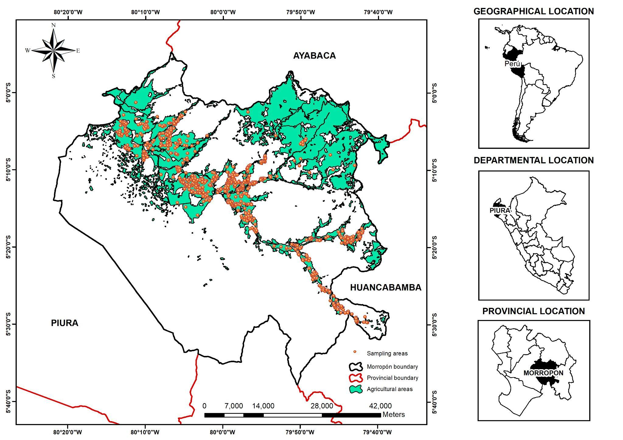
Figure 1: Location map with 1304 sampling points in Morropón Province.

Soil Sampling
Soil sampling was conducted following the procedure described by Havlin et al., (2016). Sampling was carried out during the 2024–2025 agricultural season, and each sample corresponded to a homogeneous management unit, delineated based on slope, soil texture and color, and limited to a maximum area of 3 ha. Within each unit, ten subsamples were randomly collected from the 0–30 cm soil layer and subsequently composited to obtain a single representative sample. In total, 1304 composite soil samples were collected from mango and banana fields in Morropon Province, Piura region (Figure 1).

Soil analysis
Soil samples were analyzed at the Network of Soil, Water and Foliar Laboratories of the National Institute of Agrarian Innovation (LABSAF-INIA). Samples were pretreated, air-dried at < 40 °C and sieved to < 2 mm (International Organization for Standardization, 2006). Soil texture was determined by the Bouyoucos hydrometer method (Secretaría de Medio Ambiente y Recursos Naturales (SEMARNAT), 2002). Soil pH was measured following the standardized EPA 9045D method (U.S. Environmental Protection Agency, 2015). Electrical conductivity (EC) was measured according to ISO 11265:1994/Cor.1:1996. To convert EC measured in diluted soil–water extracts to the electrical conductivity of the saturated paste extract (ECₑ), we followed the procedure proposed by Kargas et al., (2022):
$$EC_{e}=\left(1.054+\frac{283.4}{49.699+0.524×Clay\%-0.339×Sand\%}\right)×EC_{1:5}$$
Soil organic matter was estimated by the Walkley–Black method (Walkley & Black, 1934). Exchangeable bases (Ca²⁺, Mg²⁺, K⁺ and Na⁺) were extracted with ammonium acetate and quantified following Thomas (1982). Effective cation exchange capacity (ECEC) was calculated as the sum of exchangeable cations. Bulk density (g cm⁻³) was estimated using pedotransfer functions reported by Manrique & Jones (1991) and Rawls (1983). In general form, the pedotransfer relationship used can be expressed as:
$$BD=1.66-0.004×Clay-0.002×Silt-\left(0.005×OM\right)$$

Extraction of the Normalized Difference Vegetation Index (NDVI)
NDVI was included as an environmental covariate because vegetation vigor integrates the combined effects of soil fertility, moisture availability, salinity, and sodicity under field conditions. Although NDVI does not directly measure soil properties, it serves as an indirect proxy for soil functional condition and has been widely used in digital soil mapping to improve the prediction of soil spatial variability. NDVI was computed in Google Earth Engine for the period January-December, 2024. This temporal window was chosen according to the sampling dates. Sentinel-2 SR Harmonized imagery (Level-2A) from the specified interval was used to derive NDVI, calculated as (NIR − Red) / (NIR + Red) using bands B8 and B4. A cloud-masking routine based on the QA60 quality band was applied to identify and exclude cloud-affected pixels, and only cloud-free observations were retained for analysis. Following processing, NDVI values were extracted at each soil sampling location, and each record was annotated with the sampling point coordinates and the image acquisition date. To obtain a representative annual value, the median NDVI was calculated across all cloud-free images within the selected period.

Development of the Weighted Soil Quality Index (SQIw)

Selection of the minimum data set (MDS)
Variables with skewness > 1.0 were log-transformed, and those with skewness between 0.5 and 1.0 were square-root transformed to improve distributional symmetry.
Pairwise Pearson correlations were then computed among the retained variables to detect collinearity. Variable pairs with |r| > 0.70 were considered collinear; within each collinear pair, one variable was excluded, preferentially retaining the variable that exhibited a statistically significant correlation with NDVI (p < 0.001), as these variables were considered more closely associated with crop performance and the functional response of the soil under field conditions, and/or greater analytical reliability. The remaining variables were standardized (z-score) and subjected to principal component analysis (PCA). Components with eigenvalues greater than 1 were retained, and for each retained component the two variables with the largest absolute loadings were selected to compose the MDS. The resulting MDS variables were used to construct the weighted SQIw. The MDS approach was adopted to obtain a parsimonious and non-redundant set of indicators that captured the dominant gradients of soil variability while minimizing multicollinearity among variables. Accordingly, only variables meeting the predefined statistical selection criteria were retained for SQIw construction.

Assignment of weights to the MDS variables
PCA was applied to the MDS to calculate the relative weights (Wᵢ) of each variable based on their contributions to the principal components that together accounted for at least 70% of the cumulative variance. The weight assigned to each variable was obtained as a weighted sum of its individual contributions (Cᵢⱼ), adjusted by the proportion of variance explained by each component (Vⱼ), following the expression:
$$W_{i}=\frac{\sum_{j=1}^{p}{C_{ij}}V_{j}}{\sum_{j=1}^{p}{V_{j}}}$$

Normalization of variables
The MDS variables were normalized to a dimensionless scale ranging from 0 to 1, where values approaching 1 indicate favorable soil-quality conditions and values near 0 reflect limiting conditions. Normalization was performed using threshold ranges defined in Table 1. Three scoring functions were applied: “more is better”, “less is better” and “optimal range” depending on the expected relationship between each variable and soil quality. This procedure standardized measurement units and facilitated direct comparison among the different soil-quality indicators.
Table 1: Theoretical thresholds and response types of the soil variables used for normalizing the weighted soil quality index (SQIw) in mango and banana fields.
Variable | Lmin | Lopt_low | Lopt_high | Lmax | Response type
Na (cmol kg ⁻¹) | 0.5 | — | — | 1 | Less is better
Clay (%) | 10 | 20 | 50 | 60 | Optimal range
pH | 5 | 5.8 | 7.0 | 8.0 | Optimal range
Ca (cmol kg ⁻¹) | 10 | — | — | 20 | More is better

Calculation of the weighted soil quality index (SQIw)
The SQIw was calculated by linearly combining the normalized values (Nᵢ) of the selected indicators, weighted according to their relative contributions (Wᵢ) derived from the PCA. The index was computed following the expression:
$$SQIW=\sum_{i=1}^{n}{\left(W_{i}N_{i}\right)}$$
Classified as very low (< 0.3), low (0.3–0.5), moderate (0.5–0.6), high (0.6–0.7), and very high (> 0.7).

Non-parametric comparative analysis of SQIw across different climate types and categories of saline and sodic soils.
SQIw behavior was evaluated across the climate types of the study area, classified according to SENHAMI, and across salinic–sodic soil types following Rengasamy et al. (2016). Because the variables deviated from normality, non-parametric methods were employed: the Kruskal–Wallis test was used to detect overall differences among groups, and when significant (p < 0.05), pairwise comparisons were conducted using Dunn’s test with Bonferroni correction to control for multiple comparisons.

Machine Learning–Geostatistical Spatial Prediction

Evaluated models
To model the spatial variability of the Soil Quality Index (SQIw), a hybrid approach integrating machine learning and geostatistical techniques was implemented using Python software, version 3.14.3 (Python Software Foundation, 2026). Three predictive approaches were evaluated: ordinary kriging (OK), random forest (RF), and random forest with residual kriging (RF+RK). Ordinary kriging (OK) is a classical geostatistical method that models the target variable as a realization of a spatial stochastic process based on its autocorrelation structure (Cressie, 1993), implemented using the module PyKrige (Murphy et al., 2025). Random forest (RF) is an ensemble learning technique that constructs multiple decision trees using bootstrap samples and random subsets of predictors, averaging their predictions to improve robustness and reduce variance (Breiman, 2001), implemented using the module scikit-learn (Pedregosa et al., 2011). In the RF+RK hybrid approach, residuals were calculated as the difference between observed SQIw values and those predicted by RF. Ordinary kriging was then applied to interpolate the residual surface, capturing the spatial dependence not explained by the deterministic machine learning component. Final predictions were obtained by summing the RF trend and the kriged residual surface (Hengl et al., 2007).

Model optimization
Random Forest models were optimized using Bayesian hyperparameter search with the Optuna algorithm, minimizing RMSE under cross-validation (Akiba et al., 2019). Sixty trials were performed using the TPE optimization method. The optimized hyperparameters included the number of trees, the maximum depth of the trees, the minimum number of samples per leaf, and the proportion of variables considered in each split (Supplementary Table 1).

Validation strategy and performance metrics
Predictive performance was evaluated using random cross-validation (Random CV), consisting of five randomly generated folds. This scheme primarily evaluates the interpolation capacity within the predictor space. Model accuracy was quantified using root mean square error (RMSE), mean absolute error (MAE), and coefficient of determination (R²), calculated for each fold and presented as mean ± standard deviation, implemented using the modules scikit-learn (Pedregosa et al., 2011) and NumPy (Harris et al., 2020).

Statistical comparison of models
Model performance across folds was statistically compared following Demšar (2006). The non-parametric Friedman test was applied to detect significant differences among algorithms, followed by the Nemenyi post-hoc test (α = 0.05) for pairwise comparisons, implemented using the modules SciPy (Virtanen et al., 2020) and scikit-posthocs (Terpilowski, 2019). Models sharing the same letter were considered statistically homogeneous.

Predictive covariates and variable importance
Topographic, climatic, and spectral covariates commonly used in digital soil mapping were incorporated into the modelling because of their well-established relationships with soil-forming processes and the spatial variability of soil properties (Mehnatkesh et al., 2013). The topographic covariates included elevation, slope, aspect (orientation), hillshade, Topographic Position Index (TPI), Terrain Ruggedness Index (TRI), and Topographic Wetness Index (TWI), which influence soil formation, erosion, drainage, and water redistribution across the landscape. Climatic covariates comprised precipitation and temperature. Spectral covariates included the Normalized Difference Vegetation Index (NDVI), Soil-Adjusted Vegetation Index (SAVI), Normalized Difference Water Index (NDWI), Normalized Difference Moisture Index (NDMI), Green Chlorophyll Index (GCI), Normalized Burn Ratio (NBR) and Two-band Enhanced Vegetation Index (EVI2). These spectral indices were included because vegetation condition is strongly related to soil properties, allowing indirect characterization of soil fertility and supporting the prediction of soil attributes (Falahatkar et al., 2016; Mahmoudabadi et al., 2017). Spatial coordinates (X and Y, UTM) were also included to capture broad-scale spatial trends not explained by the environmental covariates. Data processing was performed using the NumPy (Harris et al., 2020), pandas (McKinney, 2010), GeoPandas (Jordahl et al., 2020), and rasterio libraries.
The importance of the predictor characteristics was estimated using the Permutation Importance method on the best-performing model. This method evaluates the increase in the model’s prediction error (RMSE) when the values of a predictor are randomly permuted, thus breaking its relationship with the response variable (Fisher et al., 2019). This approach provides a robust and comparable measure of the actual impact of each variable on the predictive power of the model, without the bias associated with the scale or type of model.

RESULTS

Multivariate statistical analysis for selecting the MDS
The correlation matrix (Figure 2) revealed significant associations among several physicochemical soil properties. Strong positive correlations were observed between ECEC with Ca (r = 0.96) and Mg (r = 0.79), between BD and Sand (r = 0.95), and between Ca and Mg (r = 0.70). A strong negative correlation was also detected between sand and silt percentages (r = –0.86) and between BD and clay (r = –0.83). Additionally, EC, available K, and exchangeable K showed no significant correlations with NDVI (p-value < 0.001).
To avoid redundancy and ensure indicator independence in the development of the SQIw, six non-redundant variables (pH, Na, OM, Ca, Sand, and Clay) showing significant correlations with NDVI were retained as candidate variables for the PCA. The PCA was subsequently used to identify the final Minimum Data Set (MDS), consisting of the most informative indicators for SQIw construction.
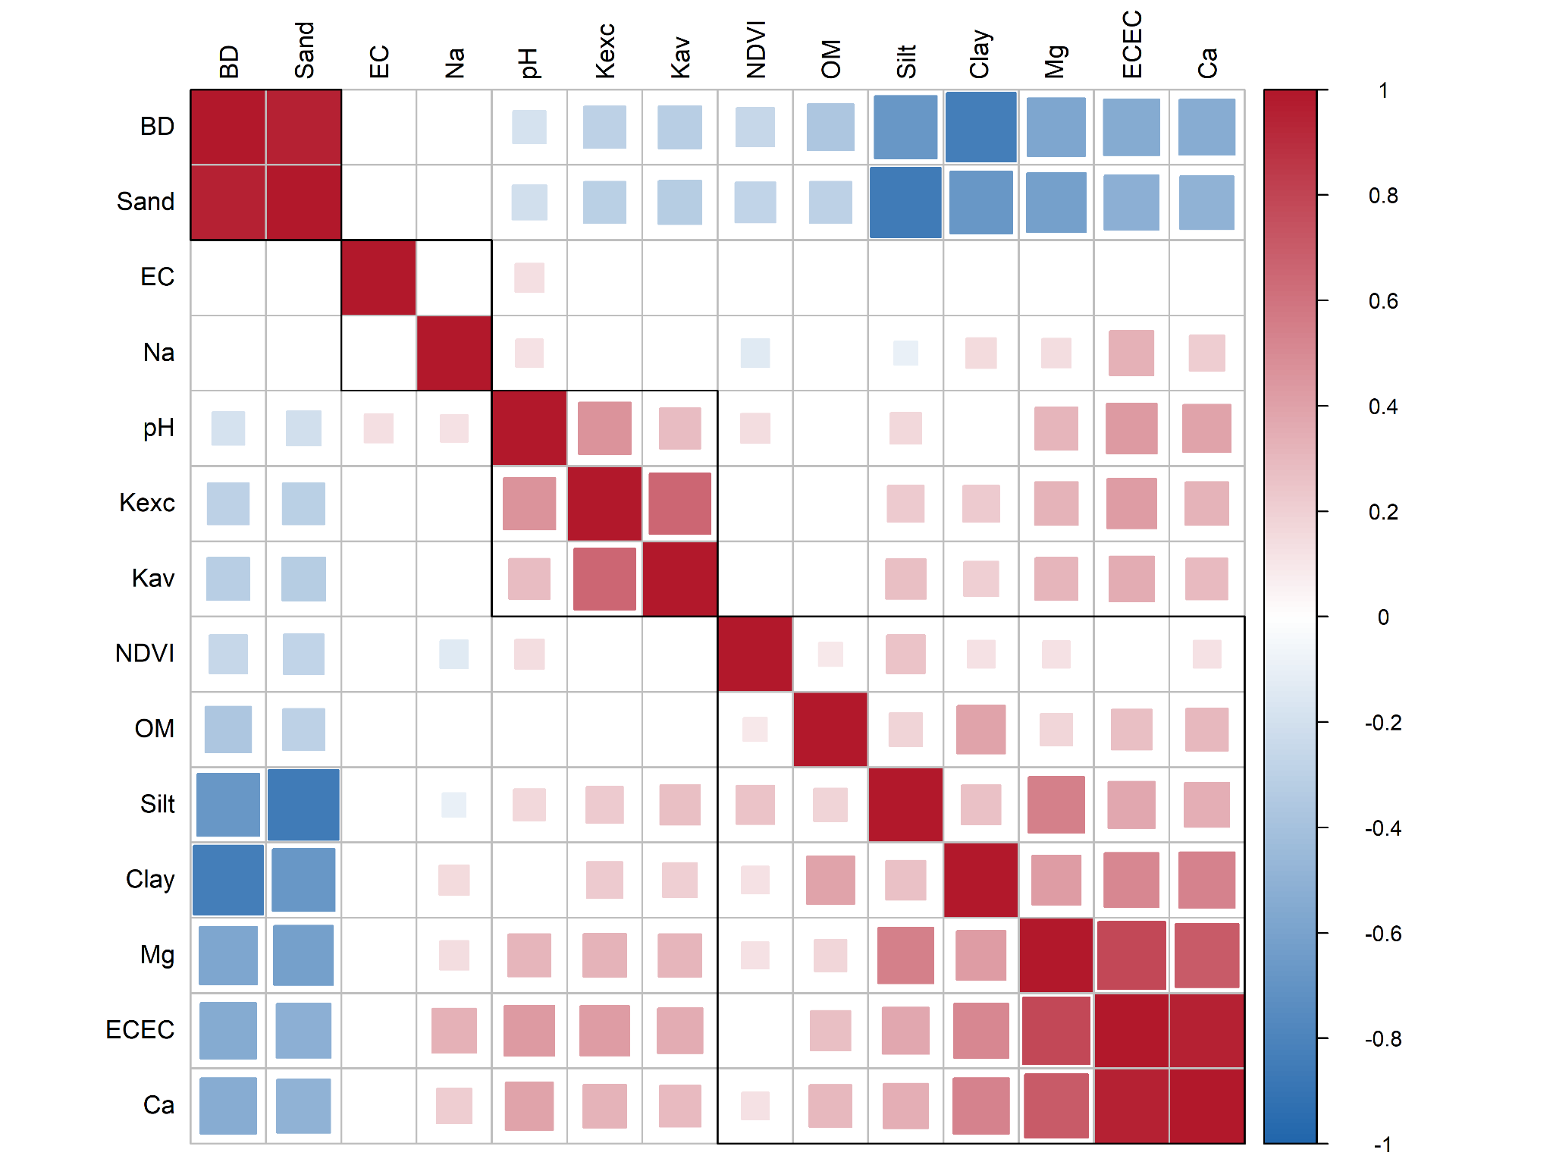
Figure 2: Pearson bivariate correlation matrix between 13 soil physicochemical variables and NDVI. Only statistically significant correlations are shown (p < 0.001).
The PCA identified two principal components (PCs) with eigenvalues > 1, together explaining 61.09% of the total variance (Table 2). PC1 accounted for 41.69% of the variance and showed strong associations with Clay (0.84), Ca (0.81), Sand (–0.80), and OM (0.55), reflecting a continuum of soil nutrient retention capacity and colloidal reactivity. PC2 (19.40%) was defined by a strong positive loading for pH (0.74) and Na (0.51), capturing the dominant gradients of alkalinity and sodicity that influence soil physical behavior. Based on the highest absolute loadings within each component, the variables selected for the Minimum Data Set (MDS) were pH, Na, Ca, and Clay. These variables captured the principal dimensions of soil variability while minimizing redundancy among indicators. Consequently, they provide a parsimonious representation of the variability contained in the complete dataset, including soil properties that were not retained in the MDS because they did not satisfy the predefined statistical selection criteria. Although variables such as EC, OM, Mg, ECEC, and K were excluded from the final index, their variability is partially represented through their relationships with the selected indicators. Therefore, while the SQIw is calculated using only four variables, it remains sensitive to identifying management zones that differ in multiple soil properties and overall soil quality.
Table 2: Principal Component Analysis (PCA) of soil variables
PCsª | PC1 | PC2 | PC3 | PC4 | PC5 | PC6
Eigenvalue | 2.50 | 1.16 | 0.97 | 0.67 | 0.41 | 0.27
Variance (%) | 41.69 | 19.40 | 16.22 | 11.24 | 6.88 | 4.57
Cumulative Variance (%) | 41.69 | 61.09 | 77.31 | 88.55 | 95.43 | 100.00
Factor loadings/eigen vector for each variable^b, c^
pH | 0.37 | 0.75 | -0.39 | 0.30 | -0.23 | 0.12
Na (cmol kg ⁻¹) | 0.25 | 0.51 | 0.79 | -0.19 | -0.12 | -0.08
OM (%) | 0.55 | -0.43 | 0.33 | 0.62 | -0.11 | -0.02
Ca (cmol kg ⁻¹) | 0.81 | 0.25 | -0.06 | 0.07 | 0.51 | -0.10
Sand (%) | -0.80 | 0.20 | 0.29 | 0.27 | 0.25 | 0.31
Clay (%) | 0.84 | -0.24 | 0.05 | -0.30 | -0.04 | 0.38

ªOnly components with eigenvalues > 1 are highlighted (Kaiser criterion). ^{b}Variables in bold denote absolute loadings ≥ 0.50. ^{c}Variables with underlined factor loadings are considered highly weighted and compose the MDS.

Edaphic influence of the MDS variables on the weighted soil quality index (SQIw)
The weighting values (Wi) derived for the MDS variables (Figure 3) reflect their relative contribution to the weighted Soil Quality Index (SQIw). Exchangeable sodium (Na) and pH showed the highest weights (Wi = 0.275 and 0.261), indicating their dominant influence on soil quality across fruit-growing areas. In contrast, Clay and Ca exhibited the lowest weights (0.243 and 0.222, respectively), suggesting more limited spatial variability despite their continued relevance to soil chemical fertility. Overall, these patterns highlight the central role of sodicity and alkalinity, followed by texture and Ca exchangeable, in shaping the edaphic conditions that govern soil aeration, moisture retention and nutrient supply.
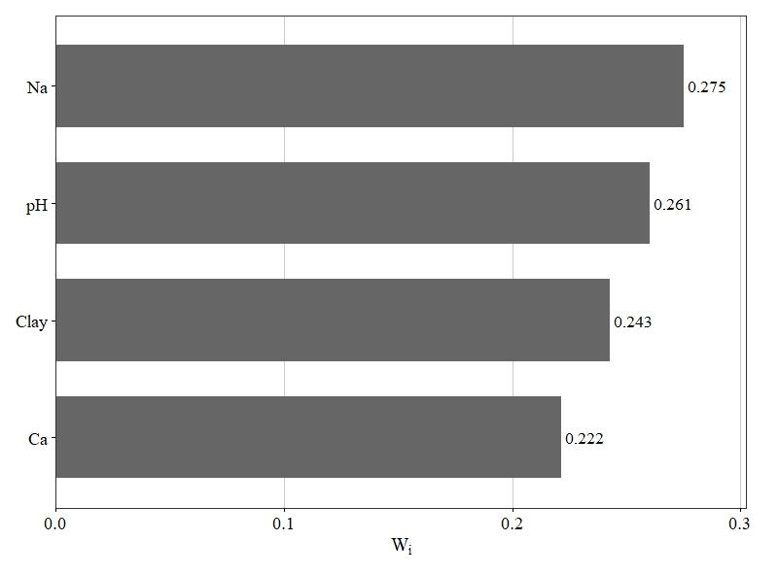
Figure 3: Relative weights (Wi) of the minimum data set (MDS) indicators used in the estimation of the weighted Soil Quality Index (SQIw).
The SQIw frequency distribution (Figure 4) exhibited an approximately normal pattern, with values ranging from 0.00 to 0.97, indicating high edaphic variability across the study area. Based on the established classification thresholds, SQIw values were grouped into five soil-quality classes: very low (< 0.30), low (0.30–0.50), moderate (0.50–0.60), high (0.60–0.70) and very high (> 0.70). The low class accounted for the largest proportion of observations (37.35%), followed by the medium (19.93%) and very high (18.71%) classes. In contrast, the high and very low classes represented only 13.96% and 10.05% of the samples, respectively. This distribution highlights the predominance of low soil-quality conditions.
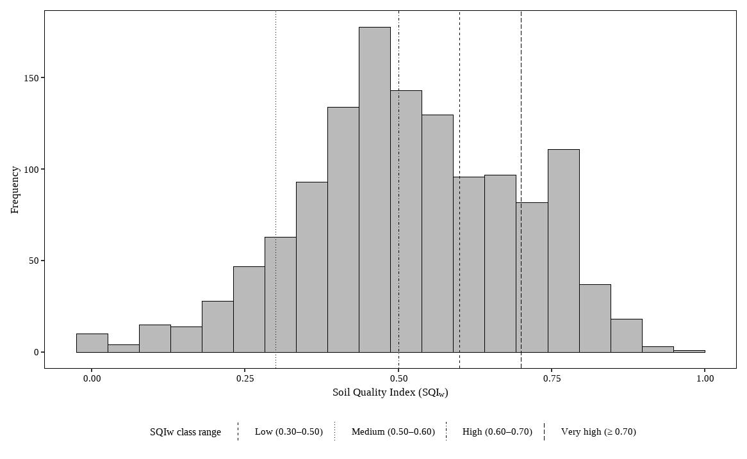
Figure 4: Distribution of the weighted Soil Quality Index (SQIw) in fruits‐growing soils from the Morropon province.
The mean values (± SD) of the SFIw variables across soil-quality classes (Table 3) reveal consistent gradients that align with the interpretation of the index. Very high–quality soils showed more balanced textural conditions, with higher sand contents (42.76 ± 15.42%) and intermediate proportions of silt and clay (31.33 ± 14.08% and 25.91 ± 7.34%, respectively). In contrast, very low-quality soils displayed a marked increase in sand content (66.15 ± 18.52%) accompanied by substantial reductions in silt (19.79 ± 12.78%) and clay (14.07 ± 10.59%), indicating a coarser and structurally weaker matrix.
Chemical indicators also exhibited clear quality-dependent patterns. Soils in the very high and high classes maintained moderate pH values (7.03 ± 0.61 and 7.35 ± 0.55) and relatively greater levels of exchangeable Ca (13.95 ± 6.54 and 12.84 ± 4.89 cmol kg⁻¹) and Mg (3.73 ± 1.48 and 3.78 ± 1.53 cmol kg⁻¹), reflecting more favorable chemical environments. In contrast, very low-quality soils showed higher pH (7.72 ± 0.54) and the lowest concentrations of Ca (8.93 ± 3.44 cmol kg⁻¹) and Mg (2.58 ± 0.92 cmol kg⁻¹), indicative of declining base status.
Sodicity increased markedly toward the lower SFIw classes, with ESP rising from 1.73 ± 1.33% in very high-quality soils to 11.51 ± 7.03% in very low-quality soils. This pattern is consistent with the strong negative correlation of ESP with the index (r = –0.62). Exchangeable Na followed a similar trend, showing a progressive increase from 0.31 ± 0.27 to 1.71 ± 1.42 cmol kg⁻¹ across the gradient. Organic matter showed a modest decline from very high to very low quality (1.79 ± 0.61% vs. 1.35 ± 0.62%), in alignment with its positive correlation (r = 0.27).
BD showed a slight but systematic increase from 1.49 ± 0.04 to 1.56 ± 0.06 g cm⁻³, consistent with its negative association with SFIw (r = –0.37), indicating gradual compaction or reduced structural integrity in lower-quality soils. EC and K did not show consistent monotonic trends across classes, which corresponds with their low Pearson correlations (r = –0.04 and r = 0.11, respectively).
Overall, the SFIw classes reflect coherent and interpretable shifts in texture, sodicity, base cation status, pH, and bulk density, effectively capturing the multidimensional degradation gradient represented in the dataset.
Table 3: Mean values of the soil variables across different SQIw classes
Variable | Pearson correlation | SQIw
 |  | Very high | High | Medium | Low | Very low
Sand (%) | -0.34 | 42.76 ± 15.42 | 39.23 ± 19.24 | 44.88 ± 18.91 | 48.97 ± 18.64 | 66.15 ± 18.52
Silt (%) | 0.24 | 31.33 ± 14.08 | 34.61 ± 15.62 | 30.95 ± 15.23 | 29.05 ± 14.06 | 19.79 ± 12.78
Clay (%) | 0.41 | 25.91 ± 7.34 | 26.16 ± 10.46 | 24.18 ± 10.64 | 21.99 ± 10.56 | 14.07 ± 10.59
pH | -0.35 | 7.03 ± 0.61 | 7.35 ± 0.55 | 7.16 ± 0.63 | 7.64 ± 0.61 | 7.72 ± 0.54
OM (%) | 0.27 | 1.79 ± 0.61 | 1.69 ± 0.55 | 1.54 ± 0.56 | 1.48 ± 0.64 | 1.35 ± 0.62
EC (dS m ⁻¹) | -0.04 | 16.10 ± 44.60 | 11.25 ± 11.99 | 13.35 ± 22.21 | 13.41 ± 15.33 | 10.77 ± 11.18
ESP (%) | -0.62 | 1.73 ± 1.33 | 3.11 ± 2.41 | 5.96 ± 4.87 | 7.09 ± 5.94 | 11.51 ± 7.03
K (mg kg ⁻¹⁾ | 0.11 | 140.39 ± 127.13 | 161.03 ± 118.26 | 130.05 ± 105.45 | 143.74 ± 117.44 | 116.50 ± 211.87
Ca (cmol kg ⁻¹) | 0.23 | 13.95 ± 6.54 | 12.84 ± 4.89 | 12.07 ± 4.92 | 13.49 ± 6.89 | 8.93 ± 3.44
Mg (cmol kg ⁻¹) | 0.15 | 3.73 ± 1.48 | 3.78 ± 1.53 | 3.65 ± 1.42 | 3.92 ± 1.67 | 2.58 ± 0.92
Na (cmol kg ⁻¹) | -0.53 | 0.31 ± 0.27 | 0.61 ± 0.61 | 1.13 ± 1.00 | 1.55 ± 2.24 | 1.71 ± 1.42
ECEC (cmol kg ⁻¹) | 0.13 | 19.69 ± 7.80 | 18.99 ± 6.28 | 18.56 ± 6.39 | 20.81 ± 9.10 | 14.94 ± 4.46
BD (g cm ⁻³) | -0.37 | 1.49 ± 0.04 | 1.48 ± 0.05 | 1.49 ± 0.05 | 1.51 ± 0.05 | 1.56 ± 0.06

Non-parametric comparison of the SQIw across different saline and sodic soil types and climate types
The SQIw exhibited systematic differences among saline and sodic soil types (Figure 5a), supporting its utility as a multivariate indicator to identify gradients of chemical and physical degradation. Median comparisons revealed multiple statistically significant differences (adjusted p < 0.0001) between categories. Alkaline saline–sodic soils (median = 0.34), neutral saline–sodic soils (0.42) and alkaline saline soils (0.46) showed significantly lower SQIw values compared with acidic saline soils (0.75), neutral saline soils (0.61) and non-salt-affected soils (0.60). These patterns indicate that not all salinity affects SQIw in the same way: soils dominated by alkaline sodicity tend to depress the index markedly, whereas certain slightly acidic and neutral saline soils retain properties that sustain a relatively high SQIw.
The non-parametric analysis of SQIw across SENAMHI climate types revealed significant differences (adjusted p < 0.0001) among specific categories (Figure 5b), thereby confirming the index’s sensitivity to the dominant climatic gradients within the study area. In particular, climates classified as D(i,p)A’ (warm semi-arid regimes with marked seasonal precipitation) exhibited significantly higher SQIw values (median = 0.54) than those classed as E(d)A’ (arid to hyperarid regimes with persistent annual moisture deficit; median = 0.46). No statistically significant differences were observed for the remaining pairwise climate comparisons, a result attributable in part to limited sample sizes for some classes.
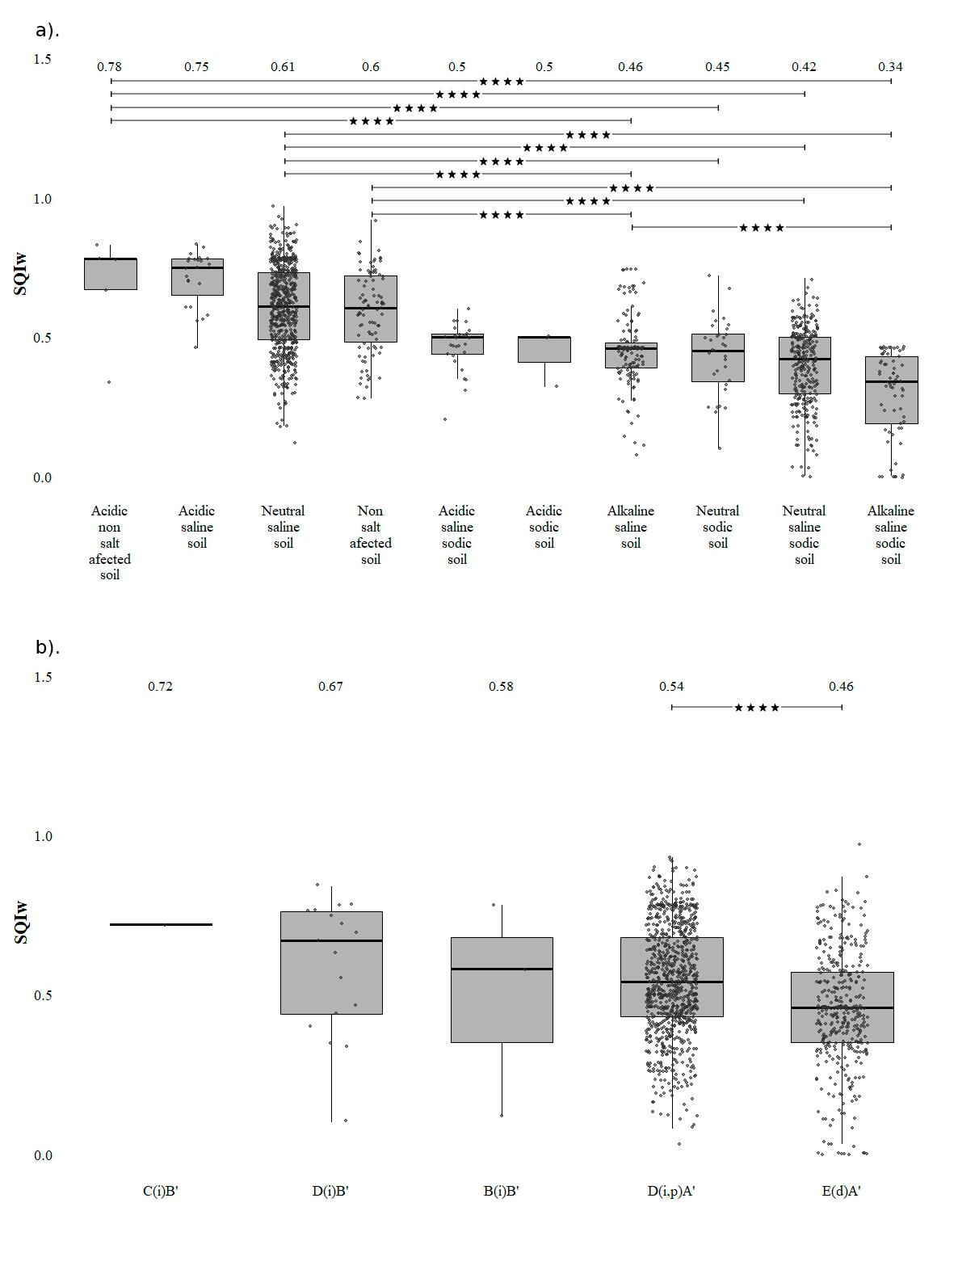
Figure 5: Comparison of SQIw across different saline and sodic soil types (a) and climate types (b) in the province of Morropón, based on Dunn’s post hoc test applied after the Kruskal–Wallis test, with Bonferroni correction for multiple comparisons. Statistical significance indicates differences at adjusted p < 0.0001.

Predictive performance of machine learning and geostatistical models for SQIw
Cross-validation under random CV showed statistically significant differences between models (Table 4). Model performance was evaluated using RMSE, MAE, R², nRMSE, relative error (RelError), and correlation coefficient (CC), calculated for each fold and reported as mean ± standard deviation. The nonparametric Friedman test detected significant differences in predictive accuracy between algorithms (α = 0.05), and pairwise comparisons were performed using the Nemenyi post hoc test. Models sharing the same letter belong to a statistically homogeneous group.
Ordinary kriging (OK) showed the lowest predictive performance, with RMSE = 0.1545 ± 0.0072, MAE = 0.1245 ± 0.0073, nRMSE = 29.809 ± 1.612%, and RelError = 35.377 ± 4.638%) and lower goodness-of-fit metrics (R² = 0.2453 ± 0.0484 and CC = 0.3729 ± 0.0486) and was statistically inferior (b) to machine learning-based approaches. In contrast, the Random Forest (RF) model improved predictive accuracy by reducing both absolute and relative errors while increasing explanatory and predictive power (R² = 0.3352 ± 0.0271 and CC = 0.5062 ± 0.0178).
The hybrid RF + residual Kriging (RF+RK) model achieved the best performance, with the lowest prediction errors (RMSE = 0.1441 ± 0.0059; MAE = 0.1130 ± 0.0046; nRMSE = 27.781 ± 1.258%, and RelError = 31.138 ± 3.706%) and the highest coefficient of determination (R² = 0.3443 ± 0.0358) and CC (0.5321 ± 0.0252). However, according to the Nemenyi test, RF and RF+RK did not show statistically significant differences.
Table 3: Cross-validation performance metrics of predictive models for the Soil Quality Index (SQIw)
Model | RMSE (± SD) | MAE (± SD) | R² (± SD)
Ordinary Kriging | 0.1545 ± 0.0072 (b) | 0.1245 ± 0.0073 (b) | 0.2453 ± 0.0484 (b)
Random Forest (RF) | 0.1451 ± 0.0069 (a) | 0.1142 ± 0.0057 (a) | 0.3352 ± 0.0271 (a)
RF + Residual Kriging | 0.1441 ± 0.0059 (a) | 0.1130 ± 0.0046 (a) | 0.3443 ± 0.0358 (a)
Model | nRMSE (± SD) | RelError (± SD) | CC (± SD)
Ordinary Kriging | 29.809 ± 1.612 (b) | 35.377 ± 4.638(b) | 0.3729 ± 0.0486 (b)
Random Forest (RF) | 27.992 ± 1.525 (a) | 31.682 ± 3.927 (a) | 0.5062 ± 0.0178 (a)
RF + Residual Kriging | 27.781 ± 1.258 (a) | 31.138 ± 3.706 (a) | 0.5321 ± 0.0252 (a)
Values are reported as mean ± standard deviation across Random CV folds. Statistical differences among models were assessed using the Friedman test followed by the Nemenyi post-hoc test (α = 0.05). Models sharing the same letter are not significantly different.

The importance of the predictor variables was assessed using permutation importance within the Random Forest model during cross-validation (Supplementary Figure 1). The spatial coordinates (Xcoord and Ycoord) showed the greatest contribution. Among the environmental covariates, precipitation, elevation, and temperature were the most influential predictors, while spectral indices contributed to a lesser extent. Based on this analysis, a reduced RF+RK model was fitted using the most influential predictors (Ycoord, Xcoord, Precipitation, Altitude, Temperature, and TRI). This simplified model performed well in cross-validation (R² = 0.3544 ± 0.0444; RMSE = 0.1429 ± 0.0048; MAE = 0.1112 ± 0.0033; nRMSE = 27.55 ± 1.01%; RelError = 21.45 ± 0.75% and CC = 0.6013 ± 0.0322). A slight improvement was compared to the full model and offers a simpler representation of the variability of the SQIw.
The experimental variogram of the SQIw showed that spatial dependence exists, as the semivariance increased with distance (Figure 6). The residual variogram of the ordinary kriging (OK) model exhibited a reduced spatial structure, indicating that the geostatistical approach captured part of the spatial variability. In contrast, the residuals from the Random Forest (RF) model exhibited a flatter variogram with lower semivariance, suggesting that environmental covariates and spatial coordinates explained a substantial portion of the spatial pattern of the SQIw. The residual variogram of the RF+RK model exhibited behavior similar to that of the RF residuals, indicating that the additional contribution of residual kriging was limited.
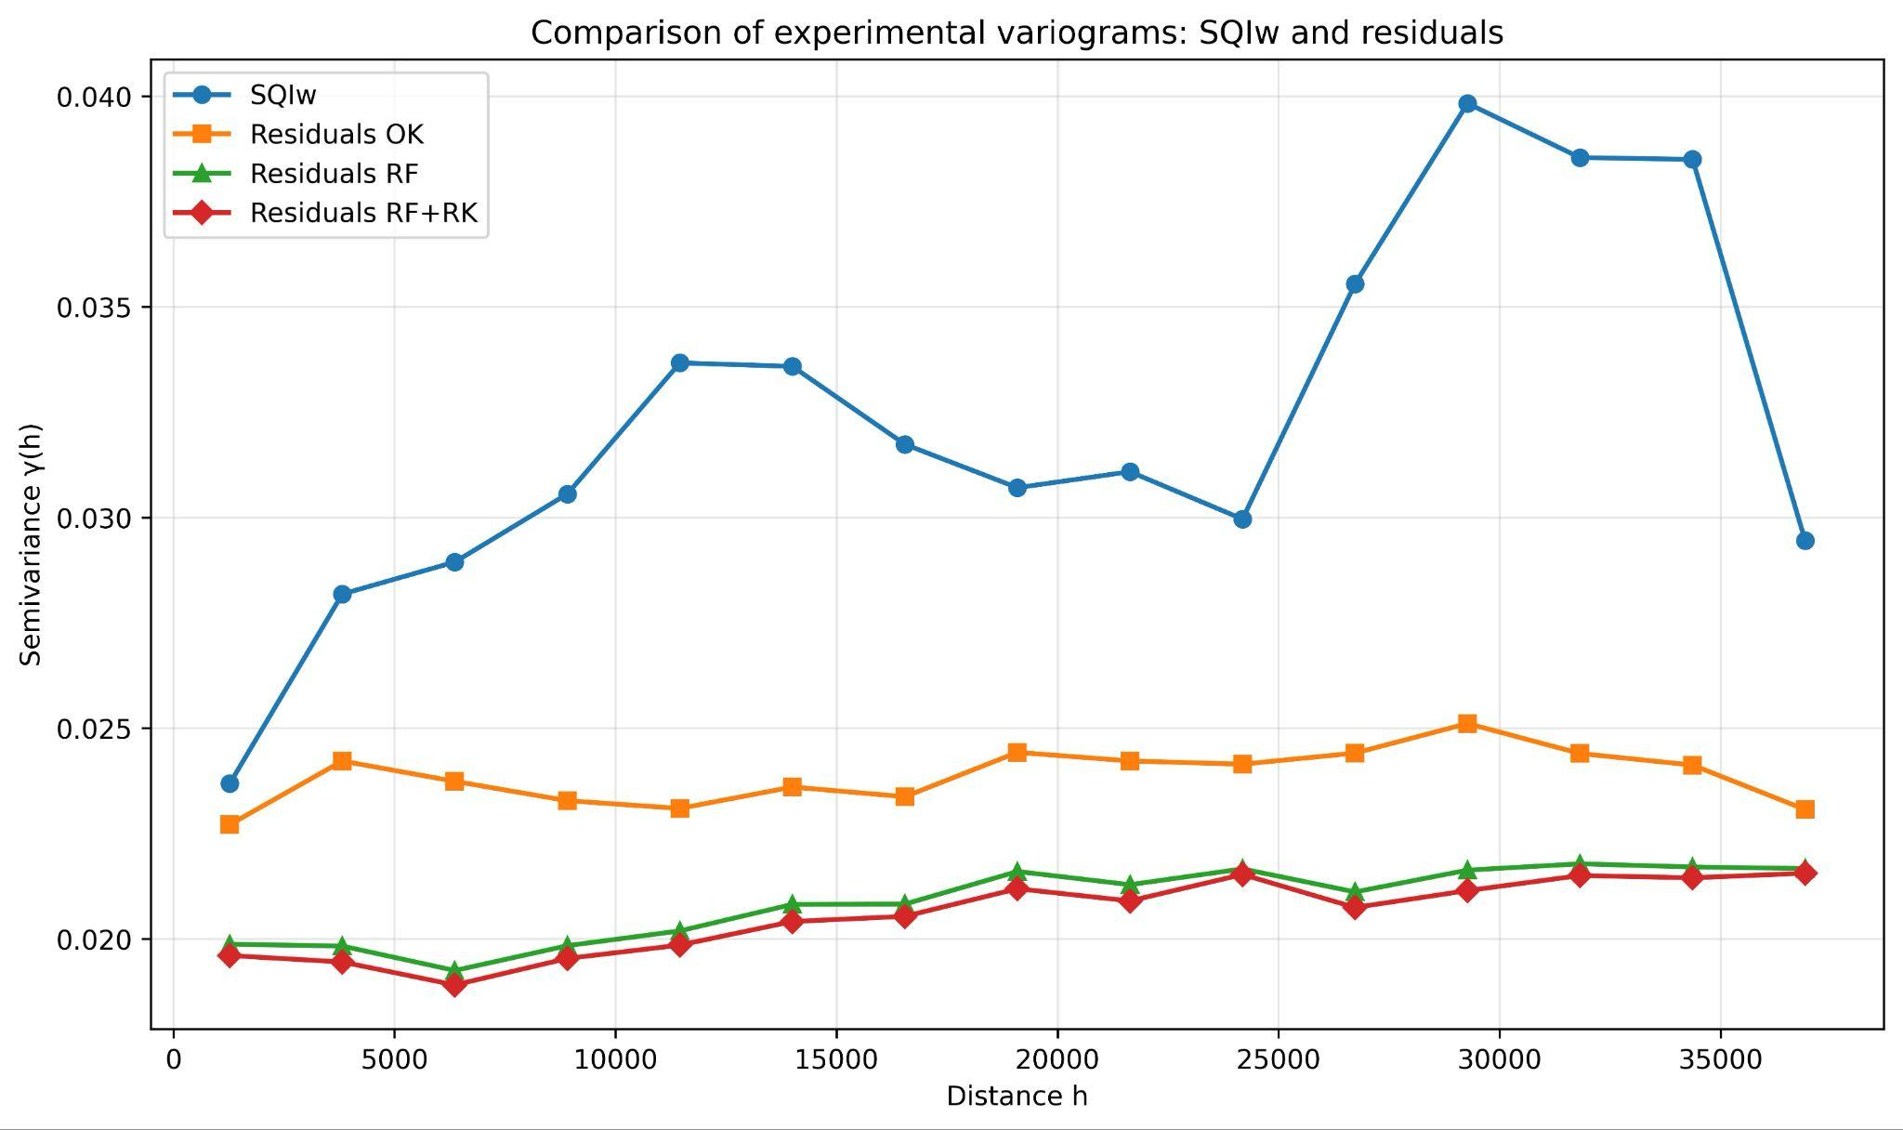
Figure 6: Experimental variograms of SQIw and residuals from the Ordinary Kriging (OK), Random Forest (RF), and Random Forest with residual kriging (RF+RK) models.
The spatial prediction map of the SQIw was generated from this reduced model, revealing clear spatial variability across the study area. An uncertainty map was also developed by combining the prediction variability from the random forest with the kriging variance of the residuals, which allowed for the identification of areas with the highest prediction uncertainty (Figure 7).
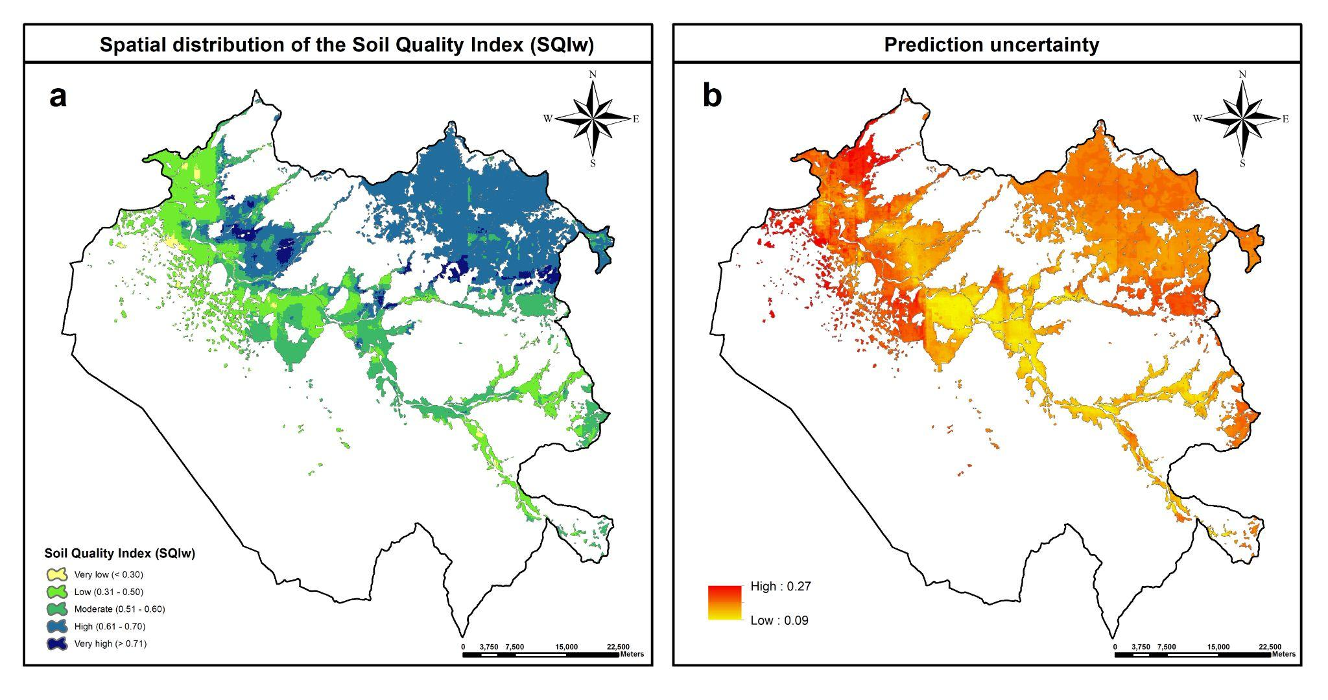
Figure 7: Spatial prediction of the Soil Quality Index (SQIw) in the agricultural area of Morropón Province, Piura, Peru. (a) Spatial distribution of SQIw predicted using the RF+RK model. (b) Spatial prediction uncertainty.
The spatial distribution of the Soil Quality Index (SQIw) in the province of Morropón’s agricultural area (Table 5) shows marked spatial heterogeneity. At the provincial level (93,886.17 ha), the low and moderate classes predominate, covering 47,246.85 ha (50.3%), with 24,082.64 ha (25.6%) classified as low and 23,164.21 ha (24.7%) as moderate. The high class represents 42,399.82 ha (45.2%), while the very high class covers 3,318.66 ha (3.5%). The very low category is marginal (920.85 ha; 1.0%) and is mainly concentrated in the Chulucanas district. At the district level, Chulucanas has the largest agricultural area (24,896.23 ha) and shows internal variability across all classes. Chalaco (12,660.15 ha) and Yamango (12,748.11 ha) have high proportions of the high class, with 11,952.53 ha and 8,325.28 ha, respectively. Meanwhile, La Matanza (10,384.32 ha) has a considerable amount of low-quality soil, with 5,266.63 ha. Santo Domingo (10,281.37 ha) is characterized by a strong predominance of the high class, with 10,198.02 ha.

Table 4: Areal distribution (ha) of Soil Quality Index (SQIw) classes within the agricultural area of each district in Morropón Province, Piura, Peru.
District | Clasificación SQIw |  |  |  |  | Total (ha)
 | Very Low | Low | Moderate | High | Very High
Buenos Aires | 0 | 758.761 | 3,640.054 | 256.582 | 20.975 | 4,676.372
Chalaco | 0 | 0 | 358.806 | 11,952.531 | 348.816 | 12,660.153
Chulucanas | 716.015 | 11,879.83 | 4,546.438 | 6,334.966 | 1,418.977 | 24,896.226
La Matanza | 73.995 | 5,266.63 | 4,805.662 | 238.037 | 0 | 10,384.324
Morropón | 1.002 | 1,078.1 | 2,223.321 | 1,398.723 | 190.383 | 4,891.529
Salitral | 129.839 | 1,928.61 | 1,892.665 | 25.927 | 0 | 3,977.041
San Juan de Bigote | 0 | 2,870.664 | 2,199.164 | 14.046 | 0 | 5,083.874
Santa Catalina de Mossa | 0 | 138.102 | 311.231 | 3,655.709 | 182.131 | 4,287.173
Santo Domingo | 0 | 0 | 60.067 | 10,198.017 | 23.288 | 10,281.372
Yamango | 0 | 161.938 | 3,126.802 | 8,325.277 | 1,134.091 | 12,748.108
Área total (ha) | 920.851 | 24,082.635 | 23,164.21 | 42,399.815 | 3,318.661 | 93,886.172

DISCUSSION

Interpretation of SQIw and its relationship to the assessment of saline, sodic and alkaline soils in arid agroecosystems on the northern Peruvian coast
The soil quality index (SQIw) integrated multiple physico-chemical attributes into a single, highly sensitive metric for diagnosing fertility in saline and sodic soils of Morropón Province, Piura. Significant correlations were observed between SQIw and exchangeable sodium percentage (ESP; r = −0.62), clay content (r = 0.41), bulk density (BD; r = −0.37), and pH (r = −0.35). Nevertheless, mean values of electrical conductivity of the saturation extract (ECe) were elevated across all soil-quality classes (10.77 ± 11.18 to 16.10 ± 44.60 dS m⁻¹). These observations are consistent with Chaudhry et al., (2024), who report the superiority of integrated soil-quality indices over univariate approaches, and with Abdu et al., (2023), who emphasize the central role of soil quality in sustainable fertilizer management.
Soils classified from medium to very low quality exhibited greater sodicity (ESP between 5.96 ± 4.87 and 11.51 ± 7.03%), concomitant with progressive increases in bulk density from 1.49 ± 0.04 to 1.56 ± 0.06 g cm⁻³. Approximately 62.84% of the total agricultural area was affected by loss of soil physical fertility (R² = 0.35; RMSE = 0.1429). The districts of La Matanza and Chulucanas accounted for the largest proportion of land with low and very low soil quality (51.42% and 50.59%, respectively). Notably, the very-low-quality class (920.85 ha) also exhibited alkalinity issues (pH = 7.72 ± 0.54) together with low K (116.50 ± 211.8 mg kg⁻¹) and Ca (8.93 ± 3.44 cmol kg⁻¹) contents.
Comparative analysis further corroborated that SQIw is highly sensitive for discriminating distinct modes of degradation in Morropón’s arid soils. Lower quality soils were classified as sodic (neutral sodic), saline-sodic (neutral saline-sodic), and alkaline saline-sodic, showing a progressive decline in quality (median SQIw values between 0.45 and 0.34). These outcomes align with climatic effects on soil quality: hyper-arid conditions, characterized by year-round water deficit, exhibited significantly lower SQIw (median = 0.46) than semi-arid environments subject to episodic rainfall (adjusted P < 0.0001).
These findings reinforce mechanistic linkages between climatic regimes and pedogenetic processes that govern soil quality in arid and semi-arid environments. In semi-arid climates with seasonal moisture pulses, infiltration and runoff events promote active transport processes, including salt redistribution and leaching of exchangeable sodium, which can ameliorate sodicity and sustain higher SQIw values (Stavi et al., 2021). Conversely, under extreme aridity, the near absence of effective moisture constrains mobility and leaching, favoring the persistence and surface accumulation of deleterious salts and, consequently, lower SQIw scores (Hassani et al., 2021). Consistent with these mechanisms, recent studies demonstrate that salinization and sodification dynamics are strongly modulated by the seasonal variability of precipitation, with direct implications for the spatial distribution of ECe and ESP (Hassani et al., 2020). Collectively, the evidence supports the use of integrated soil-quality indices as robust, sensitive tools for synthesizing multiple physico-chemical attributes and discriminating edaphoclimatic conditions of relevance to the management and remediation of saline-sodic soils.

Spatial patterns of soil quality and their agronomic significance for mango and banana systems
These edaphic constraints exert direct and synergistic impacts on the yield and nutritional status of mango and banana, which together constitute 64.5% of the crops cultivated on the soils analyzed in Morropón Province. Elevated sodicity, salinity and alkalinity are therefore principal limiting factors for the productivity of both fruit systems under arid and semi-arid conditions.
Excess exchangeable Na⁺ induces dispersion of soil fines, aggregate destabilization, reduced macroporosity and increased bulk density, with consequent declines in infiltration and effective rooting depth (Stavi et al., 2021). Such physical alterations restrict exploration of the plant-available soil volume and thereby limit water and nutrient uptake by tree crops (Priori et al., 2021). From a physiological perspective, high concentrations of sodium salts produce osmotic stress, ionic toxicity (Na⁺ and Cl⁻) and ionic imbalances. In particular, reduction of the K⁺/Na⁺ ratio and competitive displacement of Ca²⁺ diminish uptake of K, Ca and other essential nutrients, provoking chlorosis, reduced vegetative growth and losses in both yield and commercial fruit quality (Atta et al., 2023).
In mango, soil sodicity and alkalinity are associated with progressive deterioration of physiological performance and crop yield (Harhash et al., 2022; Muthuramalingam et al., 2023). Elevated ESP and pH reduce the soil’s hydraulic conductivity and structural stability throughout the profile, constraining root establishment and radial expansion and, consequently, limiting extraction of essential water and nutrients such as Ca²⁺, Mg²⁺, K⁺, Fe and Zn (Harhash et al., 2022; Stavi et al., 2021). Sodium-induced cationic displacement and the resulting decline in tissue K⁺/Na⁺ ratios compromise the selectivity of ion transporters, intensify osmotic stress, lower stomatal conductance and photosynthetic rate, and disrupt partitioning and translocation of photoassimilates to reproductive organs (Fu & Yang, 2023; Xiao & Zhou, 2023). Concurrently, functional loss of Ca²⁺ weakens membrane and cell-wall integrity, increases membrane permeability, accelerates senescence and heightens susceptibility to postharvest disorders (Hocking et al., 2016; Liu et al., 2023). These physiological pathways explain reduced floral induction, diminished fruit set and poorer fruit retention in mango orchards established on sodic and alkaline soils, and ultimately account for observed declines in productivity (Harhash et al., 2022; Muthuramalingam et al., 2023).
For banana, which relies on a superficial adventitious root system, the effects of compaction and increased bulk density associated with sodicity are particularly deleterious (Pattison et al., 2005). Restriction of root exploration reduces uptake of relatively immobile nutrients, notably K⁺ and H₂PO₄⁻, manifesting as lowered vigor and reduced bunch weight and quality. In alkaline-sodic soils (pH = 8.83; Na⁺ = 13.21 cmol kg⁻¹) elevated Na concentrations have been reported across growing tissues and markedly high Na⁺/K⁺ ratios in the pseudostem (> 3.80), limiting K accumulation in the fruit and impairing commercial quality (Thukkaram et al., 2025). This is especially critical given banana’s high K demand, with nutrient removals that may reach 480 kg ha⁻¹ (Villaseñor-Ortiz et al., 2022).
Consistent with these physiological and agronomic mechanisms, our results indicate that areas classified as high and very-high soil quality exhibit greater fertility potential for banana and mango, characterised by higher available K (140.39 ± 127.13 to 161.03 ± 118.26 mg kg⁻¹) and lower exchangeable Na⁺ (0.31 ± 0.27 to 0.61 ± 0.61 cmol kg⁻¹). Such edaphic conditions promote maintenance of K⁺/Na⁺ ionic homeostasis and a more efficient source–sink relationship between root and fruit, supporting enhanced productivity and fruit quality (Thukkaram et al., 2025).

Model performance and implications for spatial soil quality assessment
The results obtained with the random cross-validation (Random CV) scheme showed differences in model performance (Table 3). Ordinary kriging (OK) showed the lowest predictive performance, while the Random Forest (RF) model achieved an improvement in explanatory power. The hybrid RF + residual kriging (RF+RK) model presented the best predictive metrics, although its performance was not statistically superior to that of RF, but it was superior to that of OK.
The R² values obtained in this study were moderate. This result can be explained by the nature of the modeled variable and the spatial scale of the analysis. According to the findings of Patriche et al., (2023), predictive performance depends largely on the soil property being investigated. Nitrogen (N) and potassium (K) tend to show a higher correlation with remote sensing data, while phosphorus (P) is among the most difficult properties to predict, often resulting in low R² values at large spatial scales. In the present study, the response variable corresponds to a composite soil quality index derived from multiple physicochemical properties and evaluated at the provincial scale, which may explain the moderate R² values observed.
The variable importance analysis indicated that spatial coordinates (X, Y), along with precipitation, elevation, temperature, and TWI, were the most influential predictors, suggesting a strong spatial structuring of the SQIw (Supplementary Figure 1). Although previous research has shown that spectral indices such as SRI, GNDWI, or NDWI, combined with RF, can outperform single-band approaches (Pizarro et al., 2023), their contribution in this study was limited. This may be related to interannual variability and the integration of datasets from different sources and time periods, which increases the dispersion of predictors and the variability of the response (Sahabiev et al., 2021), thus introducing additional uncertainty into the modeling (Enriquez et al., 2025).
The superior performance of the RF+RK model is consistent with studies showing the benefits of integrating machine learning and geostatistics. Takoutsing & Heuvelink (2022) showed that RK outperformed RF in mapping soil pH, clay, and organic carbon, achieving lower RMSE and better extrapolation capability. However, conflicting results have also been found. Pouladi et al. (2019) observed that ordinary kriging can outperform hybrid models in certain contexts, while Suleymanov et al. (2023) demonstrated that the relative performance of RF and RK depends on the specific property of the soil or element being modeled. Furthermore, comparative studies indicate that RF tends to perform well in terms of predictive power among machine learning algorithms (Enriquez et al., 2025; Patriche et al., 2023). However, kriging has limitations related to sample density and its reduced capacity to model local variability driven by elevation, climate, or vegetation gradients (Pouladi et al., 2019). In this context, the appropriate selection of auxiliary variables can improve the performance of RF+RK, especially when there is a strong correlation between the target variable and the predictors (Gia Pham et al., 2019).
Overall, the tests used in this study suggest that the relative performance of RF, RF+RK, or OK may depend on the soil property considered, spatial dependence, and the quality of auxiliary variables, which explains the moderate improvement observed with the hybrid approach in this study.

Limitations and future perspectives
This study has some limitations that should be taken into account when interpreting the results. First, due to the complexity of accessing certain agricultural areas in the province, it was not possible to cover the entire cultivated area uniformly with soil sampling. This resulted in sectors with lower sampling density, which may have increased local uncertainty and estimated variability in those areas. This should therefore be considered in spatial extrapolation schemes. Second, the SQIw, being a composite index derived from multiple physicochemical properties, integrates different edaphic and management processes into a single metric, which may simplify the specific dynamics of each individual property. In addition, the present study represents a spatial assessment based on a single sampling campaign conducted during the 2024–2025 agricultural season. Seasonal fluctuations in soil salinity may occur due to changes in rainfall, irrigation practices, and evapotranspiration. Therefore, the resulting maps should be interpreted as representative of the prevailing conditions during the sampling period rather than as permanent soil conditions. Future studies incorporating repeated seasonal sampling would allow the assessment of temporal dynamics and further improve long-term monitoring and model robustness.
On the other hand, although topographic, climatic, and spectral covariates were incorporated, the high proportion of structural variance indicates that part of the variability of the SQIw may be due to landscape-scale processes that are not fully reflected in the variables included. Future studies could improve predictive performance by incorporating additional covariates directly related to salinity dynamics (e.g., electrical conductivity and exchangeable sodium percentage), soil moisture, irrigation conditions, and agricultural management practices, which may better represent short-term environmental variability and anthropogenic influences on soil quality. Finally, although the hybrid approach proved viable at the provincial scale, its application in other regions will require local recalibration and higher sampling density to ensure model transferability and predictive robustness.

CONCLUSIONS
This study developed a spatial predictive model to estimate the potential supply of macronutrients and agricultural gypsum requirements based on an integrated soil quality index (SQIw) in mango and banana systems in northern Peru. The development of the SQIw allowed different physicochemical attributes to be grouped into a sensitive metric for diagnosing constraints associated with salinity, sodicity, and alkalinity. The associations observed between the SQIw and variables such as the percentage of exchangeable sodium or pH show its usefulness as a diagnostic tool for assessing fertility in environments affected by salts. The comparison between OK, RF, and RF+RK showed that incorporating spatial structure improves the representation of index variability. Although the improvement of the hybrid model was moderate, the results show the integration of machine learning and geostatistics as a robust approach for digital soil mapping. For agronomic purposes, the generated map allows for the delimitation of areas with different productive potential and guides specific management decisions. This includes the differentiated application of fertilizers and agricultural gypsum to mitigate sodicity and improve nutrient availability. Overall, the proposed methodology is an important technical tool to support sustainable fertility management in agroecosystems on the northern coast of Peru.

REFERENCES
AbdelRahman, M. A. E., & Afifi, A. A. (2024). Digital mapping of soil properties using geomatics: Integration of GIS, GPS, and remote sensing applications. Arabian Journal of Geosciences, 17(12), 330. https://doi.org/10.1007/s12517-024-12132-x
Abdu, A., Laekemariam, F., Gidago, G., & Getaneh, L. (2023). Explaining the Soil Quality Using Different Assessment Techniques. Applied and Environmental Soil Science, 2023(1), 6699154. https://doi.org/10.1155/2023/6699154
Ahmad, A., Arif, M. S., Shahzad, S. M., Yasmeen, T., Shakoor, A., Iqbal, S., Riaz, A., Zahid, A., & Chapman, S. J. (2024). Long-term raw crop residue but not burned residue incorporation improved soil multifunctionality in semi-arid agroecosystems. Soil and Tillage Research, 240, 106073. https://doi.org/10.1016/j.still.2024.106073
Akiba, T., Sano, S., Yanase, T., Ohta, T., & Koyama, M. (2019). Optuna: A Next-generation Hyperparameter Optimization Framework. Proceedings of the 25th ACM SIGKDD International Conference on Knowledge Discovery & Data Mining, KDD ’19, 2623-2631. https://doi.org/10.1145/3292500.3330701
Almeida, A. M. M. de, Gomes, V. F. F., Mendes Filho, P. F., Lacerda, C. F. de, & Freitas, E. D. (2016). Influence of salinity on the development of the banana colonised by arbuscular mycorrhizal fungi. Revista Ciência Agronômica, 47, 421-428. https://doi.org/10.5935/1806-6690.20160051
Arévalo-Hernández, J. J., Oliveira, E. M. de, Ferraz, G. A. e S., Polanía-Montiel, D. C., Liscano Solano, A. L., & Silva, M. L. N. (2024). The delineation of management zones using soil quality indices for the cultivation of irrigated rice (Oryza sativa L.) in Huila, Colombia. Geoderma Regional, 39, e00886. https://doi.org/10.1016/j.geodrs.2024.e00886
Atta, K., Mondal, S., Gorai, S., Singh, A. P., Kumari, A., Ghosh, T., Roy, A., Hembram, S., Gaikwad, D. J., Mondal, S., Bhattacharya, S., Jha, U. C., & Jespersen, D. (2023). Impacts of salinity stress on crop plants: Improving salt tolerance through genetic and molecular dissection. Frontiers in Plant Science, 14. https://doi.org/10.3389/fpls.2023.1241736
Barman, A., Sheoran, P., Yadav, R. K., Abhishek, R., Sharma, R., Prajapat, K., Singh, R. K., & Kumar, S. (2021). Soil spatial variability characterization: Delineating index-based management zones in salt-affected agroecosystem of India. Journal of Environmental Management, 296, 113243. https://doi.org/10.1016/j.jenvman.2021.113243
Breiman, L. (2001). Random Forests. Machine Learning, 45(1), 5-32. https://doi.org/10.1023/A:1010933404324
Chaudhry, H., Vasava, H. B., Chen, S., Saurette, D., Beri, A., Gillespie, A., & Biswas, A. (2024). Evaluating the Soil Quality Index Using Three Methods to Assess Soil Fertility. Sensors, 24(3), 864. https://doi.org/10.3390/s24030864
Cressie, N. (1993). Spatial Prediction and Kriging. En Statistics for Spatial Data (pp. 105-209). John Wiley & Sons, Ltd. https://doi.org/10.1002/9781119115151.ch3
De Laurentiis, V., Secchi, M., Bos, U., Horn, R., Laurent, A., & Sala, S. (2019). Soil quality index: Exploring options for a comprehensive assessment of land use impacts in LCA. Journal of Cleaner Production, 215, 63-74. https://doi.org/10.1016/j.jclepro.2018.12.238
Demšar, J. (2006). Statistical Comparisons of Classifiers over Multiple Data Sets. J. Mach. Learn. Res., 7, 1-30.
Dharumarajan, S., Lalitha, M., Niranjana, K., & Hegde, R. (2022). Evaluation of digital soil mapping approach for predicting soil fertility parameters—A case study from Karnataka Plateau, India. Arabian Journal of Geosciences, 15(5), 386. https://doi.org/10.1007/s12517-022-09629-8
Diaz-Gonzalez, F. A., Vuelvas, J., Correa, C. A., Vallejo, V. E., & Patino, D. (2022). Machine learning and remote sensing techniques applied to estimate soil indicators – Review. Ecological Indicators, 135, 108517. https://doi.org/10.1016/j.ecolind.2021.108517
Doran, J. W., & Zeiss, M. R. (2000). Soil health and sustainability: Managing the biotic component of soil quality. Applied Soil Ecology, Special issue: Managing the Biotic component of Soil Quality, 15(1), 3-11. https://doi.org/10.1016/S0929-1393(00)00067-6
Enriquez, L., Ortega, K., Ccopi, D., Rios, C., Urquizo, J., Patricio, S., Alejandro, L., Oliva-Cruz, M., Barboza, E., & Pizarro, S. (2025). Detecting Changes in Soil Fertility Properties Using Multispectral UAV Images and Machine Learning in Central Peru. AgriEngineering, 7(3), 70. https://doi.org/10.3390/agriengineering7030070
Falahatkar, S., Hosseini, S. M., Ayoubi, S., & Salmanmahiny, A. (2016). Predicting soil organic carbon density using auxiliary environmental variables in northern Iran. Archives of Agronomy and Soil Science, 62(3), 375-393. https://doi.org/10.1080/03650340.2015.1051472
Fisher, A., Rudin, C., & Dominici, F. (2019). All Models are Wrong, but Many are Useful: Learning a Variable’s Importance by Studying an Entire Class of Prediction Models Simultaneously. Journal of Machine Learning Research, 20(177), 1-81.
Fu, H., & Yang, Y. (2023). How Plants Tolerate Salt Stress. Current Issues in Molecular Biology, 45(7), 5914-5934. https://doi.org/10.3390/cimb45070374
Galán Saúco, V. (2020). Nutrición y Fertilización del Mango: Revisión de Literatura. Studocu. https://www.studocu.com/co/document/universidad-nacional-abierta-y-a-distancia/agricultura-biologica/nutricion-fertilizacion-spn/65279339
Gia Pham, T., Kappas, M., Van Huynh, C., & Hoang Khanh Nguyen, L. (2019). Application of Ordinary Kriging and Regression Kriging Method for Soil Properties Mapping in Hilly Region of Central Vietnam. ISPRS International Journal of Geo-Information, 8(3), 147. https://doi.org/10.3390/ijgi8030147
Gul, N., Salam, H. A., Ashraf, M., & Taie Semiromi, M. (2025). Effect of alternating canal and marginal groundwater irrigation on banana yield, water use efficiency, and soil salinity under furrow plantation. Agricultural Water Management, 317, 109603. https://doi.org/10.1016/j.agwat.2025.109603
Harhash, M. M., Ahamed, M. M. M., & Mosa, W. F. A. (2022). Mango performance as affected by the soil application of zeolite and biochar under water salinity stresses. Environmental Science and Pollution Research, 29(58), 87144-87156. https://doi.org/10.1007/s11356-022-21503-4
Harris, C. R., Millman, K. J., van der Walt, S. J., Gommers, R., Virtanen, P., Cournapeau, D., Wieser, E., Taylor, J., Berg, S., Smith, N. J., Kern, R., Picus, M., Hoyer, S., van Kerkwijk, M. H., Brett, M., Haldane, A., del Río, J. F., Wiebe, M., Peterson, P., … Oliphant, T. E. (2020). Array programming with NumPy. Nature, 585(7825), 357-362. https://doi.org/10.1038/s41586-020-2649-2
Hassani, A., Azapagic, A., & Shokri, N. (2020). Predicting long-term dynamics of soil salinity and sodicity on a global scale. Proceedings of the National Academy of Sciences, 117(52), 33017-33027. https://doi.org/10.1073/pnas.2013771117
Hassani, A., Azapagic, A., & Shokri, N. (2021). Global predictions of primary soil salinization under changing climate in the 21st century. Nature Communications, 12(1), 6663. https://doi.org/10.1038/s41467-021-26907-3
Havlin, J. L., Tisdale, S. L., Nelson, W. L., & Beaton, J. D. (2016). Soil Fertility and Fertilizers: An introduction to nutrient management. https://bibliotecadigital.ciren.cl/items/154b5b7e-ad37-4b0a-a090-f194393cced1/full
Hengl, T., Heuvelink, G. B. M., & Rossiter, D. G. (2007). About regression-kriging: From equations to case studies. Computers & Geosciences, Spatial Analysis, 33(10), 1301-1315. https://doi.org/10.1016/j.cageo.2007.05.001
Hocking, B., Tyerman, S. D., Burton, R. A., & Gilliham, M. (2016). Fruit Calcium: Transport and Physiology. Frontiers in Plant Science, 7. https://doi.org/10.3389/fpls.2016.00569
International Organization for Standardization. (2006). Soil quality—Pretreatment of samples for physico-chemical analysis. International Organization for Standardization. https://www.iso.org/standard/37718.html
Ivushkin, K., Bartholomeus, H., Bregt, A. K., Pulatov, A., Kempen, B., & de Sousa, L. (2019). Global mapping of soil salinity change. Remote Sensing of Environment, 231, 111260. https://doi.org/10.1016/j.rse.2019.111260
Jordahl, K., Bossche, J. V. den, Fleischmann, M., Wasserman, J., McBride, J., Gerard, J., Tratner, J., Perry, M., Badaracco, A. G., Farmer, C., Hjelle, G. A., Snow, A. D., Cochran, M., Gillies, S., Culbertson, L., Bartos, M., Eubank, N., maxalbert, Bilogur, A., … Leblanc, F. (2020). geopandas/geopandas: V0.8.1 [Software]. Zenodo. https://doi.org/10.5281/zenodo.3946761
Kargas, G., Londra, P., & Sotirakoglou, K. (2022). The Effect of Soil Texture on the Conversion Factor of 1:5 Soil/Water Extract Electrical Conductivity (EC1:5) to Soil Saturated Paste Extract Electrical Conductivity (ECe). Water, 14(4), 642. https://doi.org/10.3390/w14040642
Lawrence, P. G., Roper, W., Morris, T. F., & Guillard, K. (2020). Guiding soil sampling strategies using classical and spatial statistics: A review. Agronomy Journal, 112(1), 493-510. https://doi.org/10.1002/agj2.20048
Liu, B., Xin, Q., Zhang, M., Chen, J., Lu, Q., Zhou, X., Li, X., Zhang, W., Feng, W., Pei, H., & Sun, J. (2023). Research Progress on Mango Post-Harvest Ripening Physiology and the Regulatory Technologies. Foods, 12(1), 173. https://doi.org/10.3390/foods12010173
Mahmoudabadi, E., Karimi, A., Haghnia, G. H., & Sepehr, A. (2017). Digital soil mapping using remote sensing indices, terrain attributes, and vegetation features in the rangelands of northeastern Iran. Environmental Monitoring and Assessment, 189(10), 500. https://doi.org/10.1007/s10661-017-6197-7
Manrique, L. A., & Jones, C. A. (1991). Bulk Density of Soils in Relation to Soil Physical and Chemical Properties. Soil Science Society of America Journal, 55(2), 476-481. https://doi.org/10.2136/sssaj1991.03615995005500020030x
Mao, D., Wang, Z., Wu, B., Zeng, Y., Luo, L., & Zhang, B. (2018). Land degradation and restoration in the arid and semiarid zones of China: Quantified evidence and implications from satellites. Land Degradation & Development, 29(11), 3841-3851. https://doi.org/10.1002/ldr.3135
Matazi, A. K., Gognet, E. E., & Kakaï, R. G. (2024). Digital soil mapping: A predictive performance assessment of spatial linear regression, Bayesian and ML-based models. Modeling Earth Systems and Environment, 10(1), 595-618. https://doi.org/10.1007/s40808-023-01788-1
McKinney, W. (2010). Data Structures for Statistical Computing in Python. SciPy 2010. https://doi.org/10.25080/Majora-92bf1922-00a
Mehnatkesh, A., Ayoubi, S., Jalalian, A., & Sahrawat, K. L. (2013). Relationships between soil depth and terrain attributes in a semi arid hilly region in western Iran. Journal of Mountain Science, 10(1), 163-172. https://doi.org/10.1007/s11629-013-2427-9
Ministerio de Desarrollo Agrario y Riego, M. (2025). Sistema Integrado de Estadísticas Agrarias. https://siea.midagri.gob.pe/portal/
Muñoz-Rojas, M. (2018). Soil quality indicators: Critical tools in ecosystem restoration. Current Opinion in Environmental Science & Health, Sustainable soil management and land restoration, 5, 47-52. https://doi.org/10.1016/j.coesh.2018.04.007
Murphy, B., Yurchak, R., & Müller, S. (2025). PyKrige: Kriging Toolkit for Python. (Versión 1.7.3) [Python; MacOS, Microsoft, Unix]. https://doi.org/10.5281/zenodo.17372225
Muthuramalingam, P., Muthamil, S., Shilpha, J., Venkatramanan, V., Priya, A., Kim, J., Shin, Y., Chen, J.-T., Baskar, V., Park, K., & Shin, H. (2023). Molecular Insights into Abiotic Stresses in Mango. Plants, 12(10), 1939. https://doi.org/10.3390/plants12101939
Naorem, A., Jayaraman, S., Dang, Y. P., Dalal, R. C., Sinha, N. K., Rao, C. S., & Patra, A. K. (2023). Soil Constraints in an Arid Environment—Challenges, Prospects, and Implications. Agronomy, 13(1), 220. https://doi.org/10.3390/agronomy13010220
Navamani, C. (2025). The Majesty of Mangoes: A Guide to Introduction of Mango Farm Cultivation. International Journal of Innovative Science and Research Technology, 4549-4552. https://doi.org/10.38124/ijisrt/25may2178
Padarian, J., Minasny, B., & McBratney, A. B. (2020). Machine learning and soil sciences: A review aided by machine learning tools. SOIL, 6(1), 35-52. https://doi.org/10.5194/soil-6-35-2020
Patriche, C. V., Roşca, B., Pîrnău, R. G., & Vasiliniuc, I. (2023). Spatial modelling of topsoil properties in Romania using geostatistical methods and machine learning. PLOS ONE, 18(8), e0289286. https://doi.org/10.1371/journal.pone.0289286
Pattison, T., Smith, L., Moody, P., Armour, J., Badcock, K., Cobon, J., Rasiah, V., Lindsay, S., & Gulino, L. (2005). Banana root and soil health project-Australia. International Network for the Improvement of Banana and Plantain (INIBAP). En Banana Root System: Towards a Better Understanding for Its Productive Management: Proceedings of an International Symposium Held in San José, Costa Rica, 3-5 November 2003 (pp. 149-165). Bioversity International.
Pedregosa, F., Varoquaux, G., Gramfort, A., Michel, V., Thirion, B., Grisel, O., Blondel, M., Prettenhofer, P., Weiss, R., Dubourg, V., Vanderplas, J., Passos, A., Cournapeau, D., Brucher, M., Perrot, M., & Duchesnay, É. (2011). Scikit-learn: Machine Learning in Python. Journal of Machine Learning Research, 12(85), 2825-2830.
Pizarro, S., Pricope, N. G., Figueroa, D., Carbajal, C., Quispe, M., Vera, J., Alejandro, L., Achallma, L., Gonzalez, I., Salazar, W., Loayza, H., Cruz, J., & Arbizu, C. I. (2023). Implementing Cloud Computing for the Digital Mapping of Agricultural Soil Properties from High Resolution UAV Multispectral Imagery. Remote Sensing, 15(12), 3203. https://doi.org/10.3390/rs15123203
Poma-Chamana, R., Vilca-Gamarra, C., Hermoza, N., Mercado, R., Mejía, S., Rengifo, R., & Quispe, K. (2025). Estimation and mapping of soil fertility index in arid agricultural environments of the Tambo Valley using regression kriging. Frontiers in Soil Science, 5. https://doi.org/10.3389/fsoil.2025.1706974
Pouladi, N., Møller, A. B., Tabatabai, S., & Greve, M. H. (2019). Mapping soil organic matter contents at field level with Cubist, Random Forest and kriging. Geoderma, 342, 85-92. https://doi.org/10.1016/j.geoderma.2019.02.019
Priori, S., Pellegrini, S., Vignozzi, N., & Costantini, E. A. C. (2021). Soil Physical-Hydrological Degradation in the Root-Zone of Tree Crops: Problems and Solutions. Agronomy, 11(1), 68. https://doi.org/10.3390/agronomy11010068
PROMPERÚ. (2024). Resultados de Exportaciones 2024. https://exportemos.pe/recurso/31539/resultados-de-exportaciones-peru-2024
Python Software Foundation. (2026). Python (Versión 3.14.3) [Software]. https://www.python.org/
Rabot, E., Guiresse, M., Pittatore, Y., Angelini, M., Keller, C., & Lagacherie, P. (2022). Development and spatialization of a soil potential multifunctionality index for agriculture (Agri-SPMI) at the regional scale. Case study in the Occitanie region (France). Soil Security, 6, 100034. https://doi.org/10.1016/j.soisec.2022.100034
Rawls, W. J. (1983). ESTIMATING SOIL BULK DENSITY FROM PARTICLE SIZE ANALYSIS AND ORGANIC MATTER CONTENT1. Soil Science, 135(2), 123.
Ren, D., Wei, B., Xu, X., Engel, B., Li, G., Huang, Q., Xiong, Y., & Huang, G. (2019). Analyzing spatiotemporal characteristics of soil salinity in arid irrigated agro-ecosystems using integrated approaches. Geoderma, 356, 113935. https://doi.org/10.1016/j.geoderma.2019.113935
Sahabiev, I., Smirnova, E., & Giniyatullin, K. (2021). Spatial Prediction of Agrochemical Properties on the Scale of a Single Field Using Machine Learning Methods Based on Remote Sensing Data. Agronomy, 11(11), 2266. https://doi.org/10.3390/agronomy11112266
Schmidt, J., Fungenzi, T., Recamán, A., & Khalsa, S. D. S. (2025). Evaluation of a composite soil health index and soil microbiome in a regenerative agriculture cocoa chronosequence. Ecological Indicators, 178, 113866. https://doi.org/10.1016/j.ecolind.2025.113866
Secretaría de Medio Ambiente y Recursos Naturales (SEMARNAT). (2002). Official Mexican Standard NOM-021-RECNAT-2000. Establishing specifications for soil fertility, salinity and classification. Studies, sampling and analysis (Official Gazette of the Federation). https://www.ordenjuridico.gob.mx/Documentos/Federal/wo69255.pdf
Singh, A. (2022). Soil salinity: A global threat to sustainable development. Soil Use and Management, 38(1), 39-67. https://doi.org/10.1111/sum.12772
Stavi, I., Thevs, N., & Priori, S. (2021). Soil Salinity and Sodicity in Drylands: A Review of Causes, Effects, Monitoring, and Restoration Measures. Frontiers in Environmental Science, 9. https://doi.org/10.3389/fenvs.2021.712831
Suleymanov, A., Polyakov, V., Kozlov, A., Abakumov, E., Kuzmenko, P., & Telyagissov, S. (2023). Mapping of potentially toxic elements in the urban topsoil of St. Petersburg (Russia) using regression kriging and random forest algorithms. Environmental Earth Sciences, 82(23), 561. https://doi.org/10.1007/s12665-023-11272-9
Takoutsing, B., & Heuvelink, G. B. M. (2022). Comparing the prediction performance, uncertainty quantification and extrapolation potential of regression kriging and random forest while accounting for soil measurement errors. Geoderma, 428, 116192. https://doi.org/10.1016/j.geoderma.2022.116192
Terpilowski, M. A. (2019). scikit-posthocs: Pairwise multiple comparison tests in Python. Journal of Open Source Software, 4(36), 1169. https://doi.org/10.21105/joss.01169
Thomas, G. W. (1982). Exchangeable Cations. En Methods of Soil Analysis (pp. 159-165). John Wiley & Sons, Ltd. https://doi.org/10.2134/agronmonogr9.2.2ed.c9
Thukkaram, D., Manoharan, M., Debnath, P., Kumari, S., Kumar, S., Mishra, M., Jha, S. K., & Verma, C. L. (2025). Secondary Metabolite-Induced Osmo-Protection and Host Antioxidant Systems in Banana in Waterlogged Sodic Soils. Horticulturae, 11(4), 416. https://doi.org/10.3390/horticulturae11040416
U.S. Environmental Protection Agency. (2015, diciembre 8). SW-846 Test Method 9045D: Soil and Waste pH [Other Policies and Guidance]. https://www.epa.gov/hw-sw846/sw-846-test-method-9045d-soil-and-waste-ph
Villaseñor-Ortiz, D., Prado, R. de M., Luna-Romero, E., Jaramillo-Aguilar, E., & Agurto-Rodriguez, L. (2022). Critical nitrogen and potassium levels and sufficiency ranges for banana cultivation in Ecuador. Fruits, The International Journal of Tropical and Subtropical Horticulture, 77(1). https://doi.org/10.17660/th2022/002
Virtanen, P., Gommers, R., Oliphant, T. E., Haberland, M., Reddy, T., Cournapeau, D., Burovski, E., Peterson, P., Weckesser, W., Bright, J., van der Walt, S. J., Brett, M., Wilson, J., Millman, K. J., Mayorov, N., Nelson, A. R. J., Jones, E., Kern, R., Larson, E., … van Mulbregt, P. (2020). SciPy 1.0: Fundamental algorithms for scientific computing in Python. Nature Methods, 17(3), 261-272. https://doi.org/10.1038/s41592-019-0686-2
Walkley, A., & Black, I. A. (1934). AN EXAMINATION OF THE DEGTJAREFF METHOD FOR DETERMINING SOIL ORGANIC MATTER, AND A PROPOSED MODIFICATION OF THE CHROMIC ACID TITRATION METHOD. Soil Science, 37(1), 29.
Wang, L., Wu, W., & Liu, H.-B. (2019). Digital mapping of topsoil pH by random forest with residual kriging (RFRK) in a hilly region. Soil Research, 57(4), 387-396. https://doi.org/10.1071/SR18319
Xiao, F., & Zhou, H. (2023). Plant salt response: Perception, signaling, and tolerance. Frontiers in Plant Science, 13. https://doi.org/10.3389/fpls.2022.1053699
Yin, X., Feng, Q., Li, Y., Liu, W., Zhu, M., Xu, G., Zheng, X., & Sindikubwabo, C. (2021). Induced soil degradation risks and plant responses by salinity and sodicity in intensive irrigated agro-ecosystems of seasonally-frozen arid regions. Journal of Hydrology, 603, 127036. https://doi.org/10.1016/j.jhydrol.2021.127036

